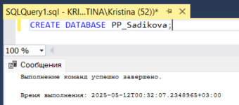

Рис 1. Создание БД

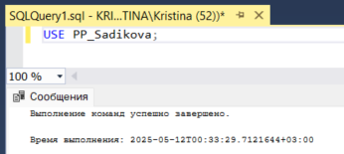

Рис 2. Подключение БД

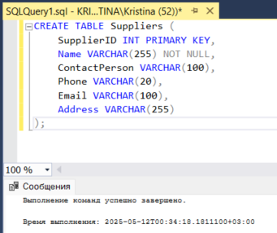

Рис 3. Создание таблицы (Скрипт)

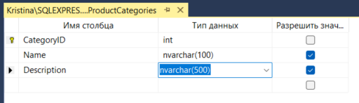

Рис 4. Создание таблицы (Вручную)

-- Создание базы данных

CREATE DATABASE PP_Sadikova;

USE PP_Sadikova;

-- Таблицы без внешних ключей (создаются первыми)

CREATE TABLE Suppliers (

SupplierID INT PRIMARY KEY,

Name NVARCHAR(100),

ContactPerson NVARCHAR(100),

Phone NVARCHAR(20),

Email NVARCHAR(100),

Address NVARCHAR(200)

);

CREATE TABLE ProductCategories (

CategoryID INT PRIMARY KEY,

Name NVARCHAR(100),

Description NVARCHAR(500)

);

CREATE TABLE Positions (

PositionID INT PRIMARY KEY,

Title NVARCHAR(100),

Salary DECIMAL(10, 2)

);

-- Таблицы, зависящие от созданных выше

CREATE TABLE Products (

ProductID INT PRIMARY KEY,

Name NVARCHAR(100),

CategoryID INT FOREIGN KEY REFERENCES ProductCategories(CategoryID),

SupplierID INT FOREIGN KEY REFERENCES Suppliers(SupplierID),

UnitPrice DECIMAL(10, 2),

UnitOfMeasure NVARCHAR(20),

Description NVARCHAR(500)

);

CREATE TABLE Employees (

EmployeeID INT PRIMARY KEY,

FirstName NVARCHAR(50),

LastName NVARCHAR(50),

PositionID INT FOREIGN KEY REFERENCES Positions(PositionID),

HireDate DATE,

Phone NVARCHAR(20),

Email NVARCHAR(100)

);

-- Таблицы, зависящие от Employees и Products

CREATE TABLE Warehouses (

WarehouseID INT PRIMARY KEY,

Location NVARCHAR(200),

Capacity INT,

ManagerID INT FOREIGN KEY REFERENCES Employees(EmployeeID)

);

CREATE TABLE Customers (

CustomerID INT PRIMARY KEY,

FirstName NVARCHAR(50),

LastName NVARCHAR(50),

Phone NVARCHAR(20),

Email NVARCHAR(100),

Address NVARCHAR(200)

);

CREATE TABLE Sales (

SaleID INT PRIMARY KEY,

CustomerID INT FOREIGN KEY REFERENCES Customers(CustomerID),

EmployeeID INT FOREIGN KEY REFERENCES Employees(EmployeeID),

SaleDate DATE,

TotalAmount DECIMAL(10, 2)

);

-- Таблицы, зависящие от Sales и Products

CREATE TABLE SaleDetails (

SaleDetailID INT PRIMARY KEY,

SaleID INT FOREIGN KEY REFERENCES Sales(SaleID),

ProductID INT FOREIGN KEY REFERENCES Products(ProductID),

Quantity INT,

UnitPrice DECIMAL(10, 2)

);

-- Таблицы, зависящие от Suppliers и Products

CREATE TABLE Orders (

OrderID INT PRIMARY KEY,

SupplierID INT FOREIGN KEY REFERENCES Suppliers(SupplierID),

ProductID INT FOREIGN KEY REFERENCES Products(ProductID),

Quantity INT,

OrderDate DATE,

DeliveryDate DATE,

Status NVARCHAR(50)

);

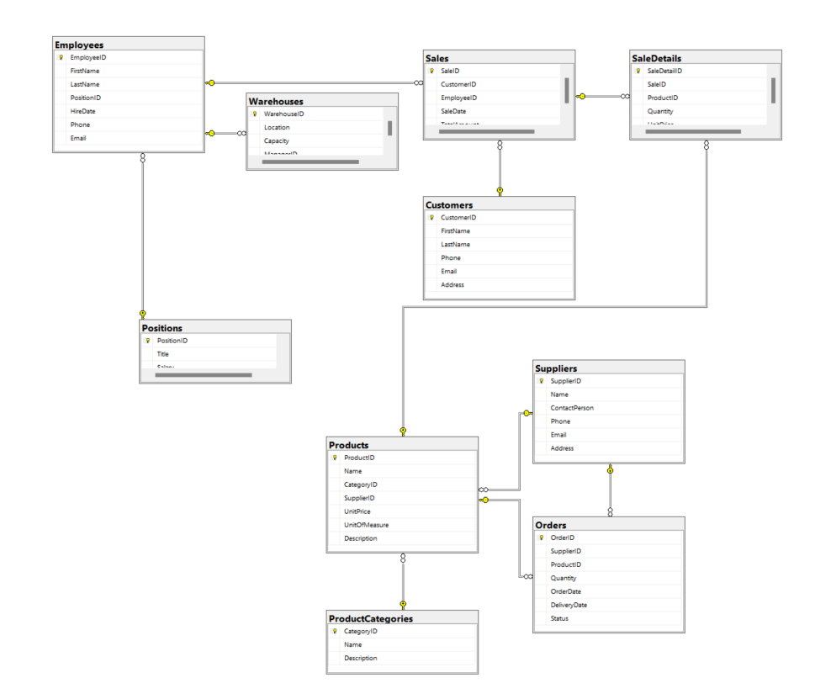

Рис 5. Диаграмма